Get Wimpy!

Reserve your copy of Wimpy Kid 6 today

Cottage Street PTO has been offered a wonderful opportunity by Scholastic for you to pre-order the paperback edition of Jeff Kinney’s newest book, Diary of a Wimpy Kid: Cabin Fever. This was the #1 requested book at book fair.
The hardcover version is scheduled to go on sale November 15. The paperback edition won’t be available to the public for months.
PTO is pre-selling the paperback version only for $8.49.
Order deadline is firm for Tuesday, October 11.
Books will be delivered shortly after November 15 and delivered to school. If you choose, as a courtesy, PTO will deliver TO YOUR HOME, books intended as surprise gifts for the holiday.
Please complete this order form and return by October 11 along with payment. Be sure to mark Att: Mary Lang, Bookfair on the outside of the envelope. Checks should be made payable to CSS PTO.
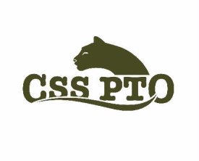
Name: ______________________________________
Grade: __________________________ Teacher: ________________________________

This is intended as a gift yes _________ no ____________
Please deliver to my home at ________________________________, Sharon, MA

Enclosed is payment for $8.49 per book (cash or check)
# of books ________________ Amount enclosed _____________________

