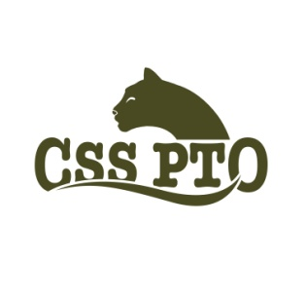
CSS PTO ANNUAL BOOK FAIR

Tuesday, September 11th
9am - 4pm and 6:30pm – 8:30pm
Wednesday, September 12th
9am - 4pm and 6:30pm-8:30pm

Scholastic Books and CSS PTO are joining forces to bring quality literature to our children. This is a great opportunity for families to purchase books and support our school. The selection of books is extensive in paperback and hardcover. There will be no posters, games or toys sold during school hours.

-Kindergarten, first and second grades will visit the Book Fair during school hours on Tuesday.
-Third, fourth and fifth grades will visit the Book Fair during school hours on Wednesday.
-Parents/guardians are welcome to attend the Book Fair during all open hours.

The Book Fair will be open after school until 4 pm and during the two Open House Nights.

Students may bring cash or check, made payable to CSS PTO, to purchase books, when their class visits the Book Fair. There will be no sales tax. Students who do not bring cash/check may complete a Wish List when their class visits the Book Fair. The Wish List will be sent home as a guide for parents who visit the Book Fair after school or in the evening.

We hope to see you at this wonderful Cottage tradition!

If you have any questions, please feel free to call Leandra McLean 781-793-0668.

Volunteers are needed!! Please email leandra.mclean@comcast.net if you can help.

